Discount for Existing MedInsight Clients
MedInsight PRM Analytics
Submitted by: Jason Altieri
Submission Date: March 9, 2018

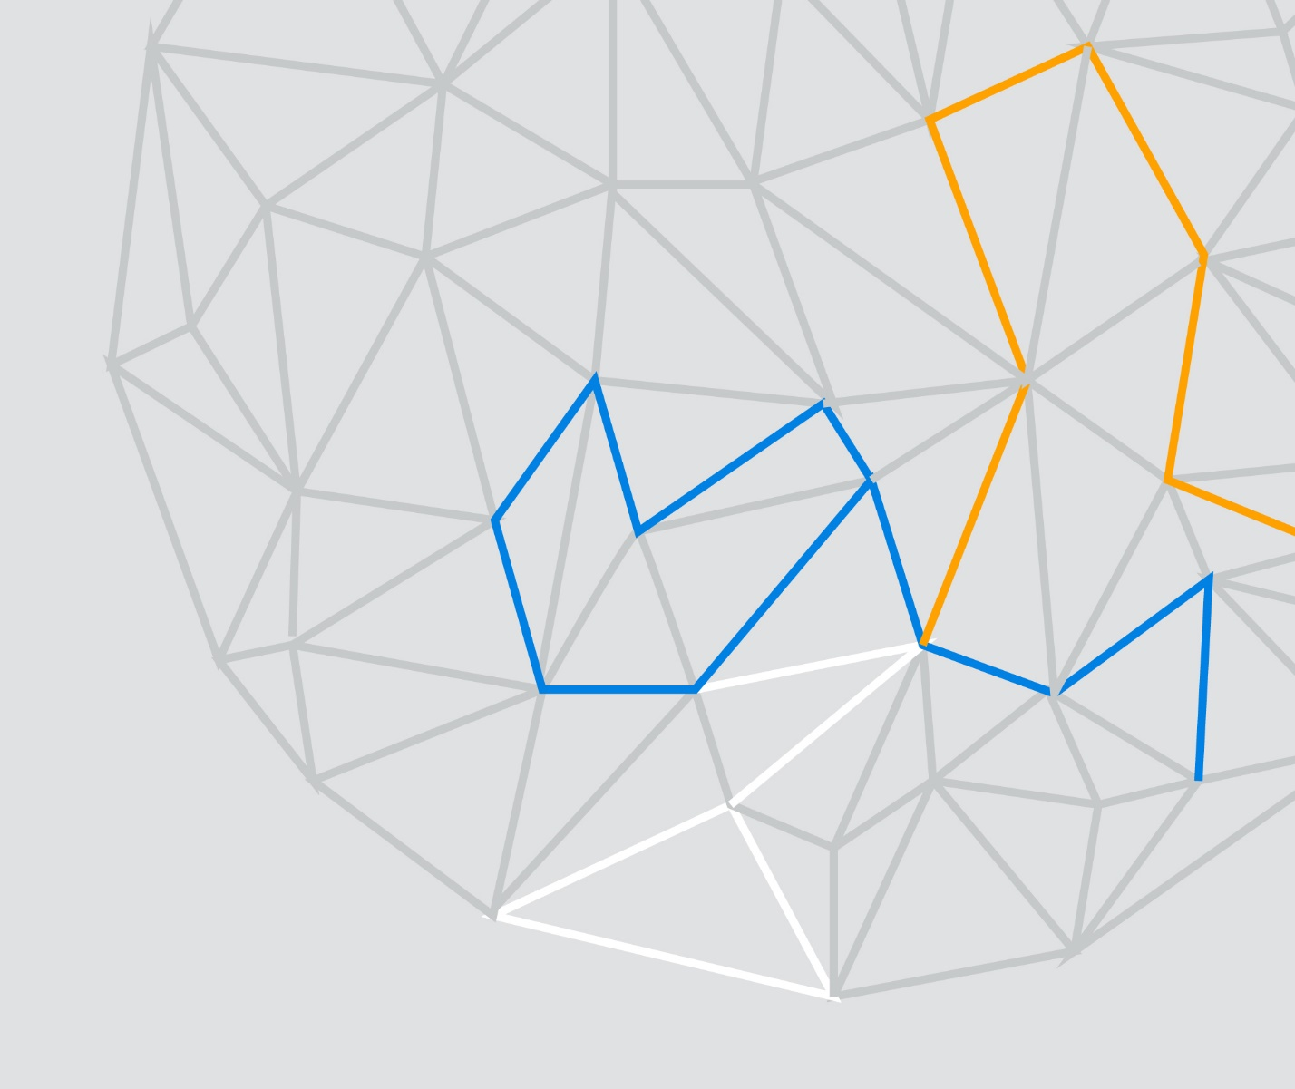

Proprietary and Confidential
This document contains proprietary and confidential information that is protected by laws pertaining to such material. This document, the information in this document, and all rights thereto are the sole and exclusive property of Milliman Solutions, LLC (hereafter referred to as Milliman) and are intended for use by prospective clients, clients and employees of Milliman, and may not be copied, used, or disclosed to anyone else, in whole or part, without the express written permission of Milliman.
Unless otherwise stated, the product names and acronyms used herein are trademarks, service marks, and registered trademarks of Milliman used under license. All other products names used herein are trademarks of their respective owners.

DISCOUNT OFFER FOR MEDINSIGHT CLIENTS
- 10% off the annual license fee for each data feed received through MedInsight
- Implementation fee reduced to $30,000 one-time for all data feeds that come through MedInsight

APPLICABILITY
These discounts only apply to data feeds processed through the MedInsight core engine. Any additional data feeds outside of those processed by MedInsight will be subject to the full implementation and license fees.
These discounts assume that PRM will use the user-defined fields populated within MedInsight. Additional implementation fees may apply to incorporate client-provided reference data.
These discounts only apply as long as the client continues to supply data through MedInsight. In the event a client stopped providing data through MedInsight the discounts would terminate and full implementation fees would be due to accept the data feeds directly.

EXAMPLE SCENARIOS
Scenarios assume monthly delivery of a data feed that contains the following elements as defined in the reseller agreement:
- HCC Risk Scores
- HCG Benchmarks
- PAC/Grouping/Benchmarks
- Key Claims Metrics
- Waste Calculator
- Medical Conditions
Data feeds are assumed to be non-CCLF with an average of 50,000 lives each for the purpose of this illustration.
Raw Data Feeds | Implementation | Annual License | Implementation With Discount | Annual License With Discount | Year 1 Savings
3 | $98,250 | $159,080 | $30,000 | $143,172 | $84,158
4 | $131,000 | $197,880 | $30,000 | $101,000 | $120,788
5 | $163,750 | $236,680 | $30,000 | $213,012 | $157,418

